CHAPTER 9
COMMUNITY DESIGN

CITY DESIGN

The population of Lewisville had reached 313 people by 1904. On January 15, 1904, a document creating the Village of Lewisville was recorded at the Fremont County Courthouse. Richard F. Jardine, William W. Selck, Jr., Arthur Goody, Jr., Welby H. Walker, and Frank Ellsworth were appointed to serve as a trustees until an election could be held. On April 16, 1904, Welby H. Walker was elected mayor, with Frank B. Ellsworth, Arthur Goody and William Farr as trustees. William Williams was appointed marshal, Edmond Ellsworth, Jr. town clerk, and Frank B. Ellsworth the treasurer.

The first proposal establishing the boundaries of the town required landowners with property adjoining the site to each donate 20 rods of their land to the town, but some objected to the proposal. Eventually, it was decided each would donate 10 rods of their adjoining land. Two owners chose not to donate, and the boundaries of the town were designed to exclude their land. The boundaries of the town have remained essentially the same as the original survey.

The town is designed in a grid pattern with 32 blocks divided into quarter sections. The full blocks measure 330 feet by 330 feet. The sections along the south side of Second North Street measure 265 feet by 330 feet; those along the east side of Lewisville Highway measure 330 feet by 270 feet; and, those along the west side of 3500 East or State Highway 48 are 262 feet by 330 feet. The blocks on Second South Street are full blocks. The city boundaries extend 10 rods, or 160 feet, from the section lines and include some homes and farmland.

On October 1, 1994, the city council enacted an ordinance defining a one-mile impact zone around the city boundaries. This area extends from 400 North and 3600 East, west on 400 North to the Lewisville Cemetery, north along the line to the dry bed of the Snake River, and then east along the dry bed to 3600 East, then south to 400 North.

Page 9-1

FIGURE 9-1
LEWISVILLE CITY - IMPACT ZONE
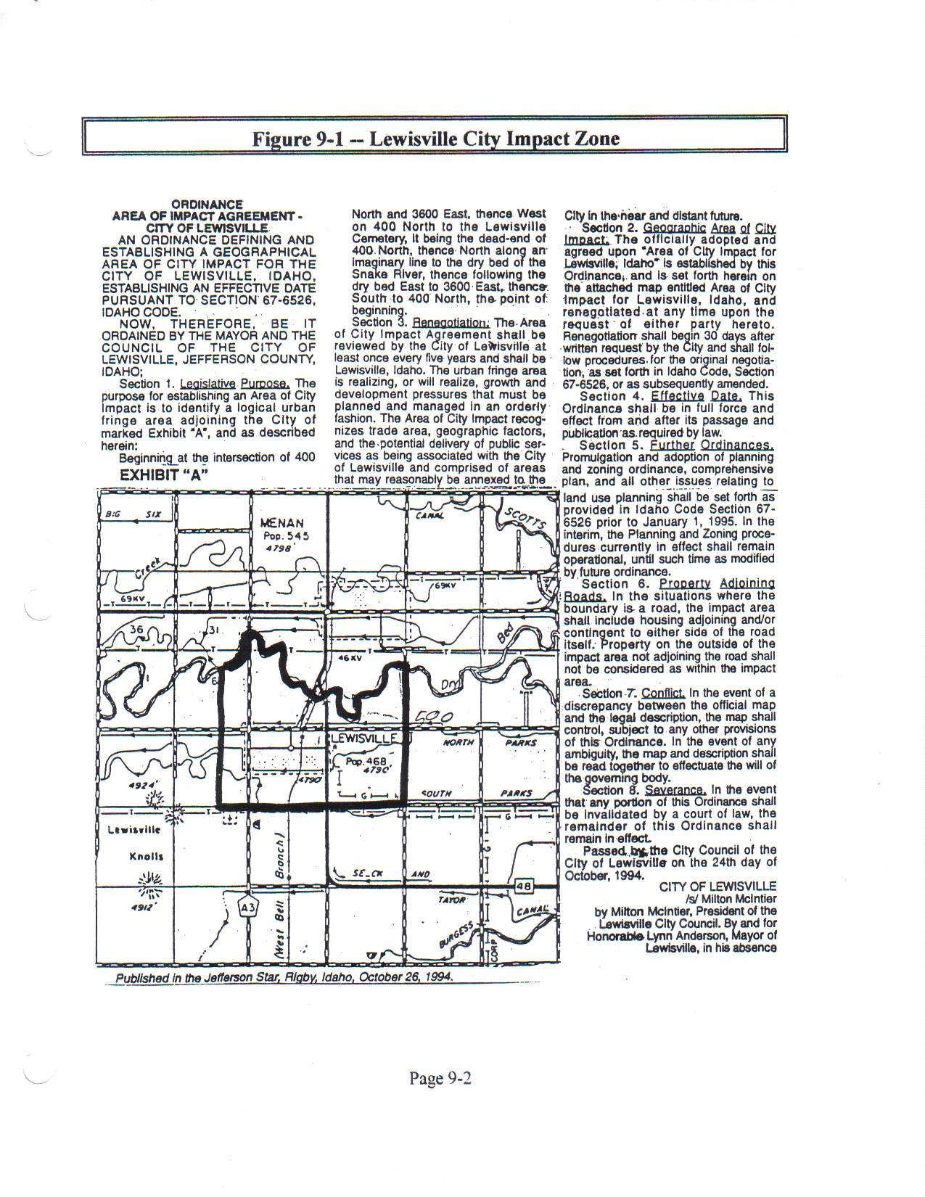
Page 9-2

STREETS

The city blocks are bisected by 24-foot wide streets, running at right angles, with the exception of Adams Street, which forks between Main Street and First North Street. First North Street dead-ends between Madison and Adams Streets, and resumes on the west intersection of Adams Street. All of the streets in Lewisville have been paved.

SIDEWALKS, CURBS, AND GUTTERS

Only two areas in the city have sidewalks. One area begins at Block 13, Sections 3 and 4, (Adams Street, past the city property to the beginning of Rounds Service property). The other area is the south side of Main Street from Block 20 to Block 22, (the LDS Church property to the corner of Lincoln Street). There are no curbs or gutters in town.

RESIDENTIAL THEME AND ARCHITECTURE

Most of the property in town is residential with adjoining pasture or garden areas. Single and double-wide trailer homes or manufactured homes are interspersed with conventional homes. Most homes are ranch-style architecture; but, there are several two-story brick or lava rock homes built at the turn of the century. The age of the homes varies from the early days of Lewisville to the present.

CITY CENTER

The city center is in Block 13, Section 3, where the City Office/Library and Community Hall are located. Central Fire District Station #3 is also found on the city property between the City Office/Library and Community Hall. Both the city buildings were constructed in the early 1900's of lava rock quarried in Menan. The fire district building is single-story, constructed of metal. There is no planned theme for the architecture of the city buildings or for residential buildings within the city limits.

Page 9-3

BUSINESS DISTRICT

Lewisville once supported a thriving business community. At this time, (1997), only a few business establishments remain. Rounds Service Station is located at 103 East Main. Kozy Kabin Log Furniture is located in the old Walker Store located at 205 South Jefferson. Idahoan Fresh, Clement Brothers, and Lewisville Produce are all separate businesses sharing the same building located at 209 East Main. Ball Brothers Produce located at 508 North 3470 East; and, Idahoan Foods and Idahoan Transportation located on 3500 East, (State Highway 48), about one-half mile north of the city limits, are within the impact area of the city.

There are a few home-based businesses within the city. Although these businesses are subject to the same city ordinances as residences within the city, there are no rules regulating truck routes, speed limits other than the 35-mile-an-hour limit in the city, employee parking, or expansion of buildings, settling ponds, or other matters specifically relating to business growth.

BEAUTIFICATION

The city currently, (1997), has no formal plan for city beautification. A park is being developed on the triangular piece of ground on Adams Street west of Clement Brothers. Grass and trees have been planted; but, there are no plans to expand the development of the park further, at present. The city hires youth to mow lawns, repair roads, and do other maintenance work during the summer. The crew is supervised by a city council member. Maintenance and repair on city buildings and lots have been postponed pending decisions on the future of city buildings that are in deteriorating condition.

The city does have nuisance ordinances designed to protect residents of the city from noise and pollution that may cause disease or effect the quality of living. These ordinances were enacted some time ago; and, although still legal and binding, they need to be updated.

Page 9-4

LIGHTING

Some areas of Lewisville are very well lit, and others are not. Currently, (1997), there are 21 streetlights in the city. All the streets entering Lewisville from the Lewisville Highway are lit. Only First South and Main Street are lit where they join 3500 East, (State Highway 48). Second North Street has three lights -- one on the Lewisville Highway, one at Second North and Washington, and one at Second North and Adams Street. First North has two lights -- one at First North and Madison Street, and one at First North and Jefferson Street. Main Street is well lit with a light at each intersection.

First South has four lights, one on every other corner. Those lights are located at First South and Highway 48, First South and Madison Street, First South and Jefferson Street, and First South and the Lewisville Highway. In addition, there is a light located at 124 South Washington, across from the LDS Church. The church property is also well-lit. The only light on Second South is on the corner of 3500 East, (State Highway 48).

The named streets between Madison and Jefferson Streets are well-lit. Lincoln, Harrison, and Monroe have only one light each.

Page 9-5

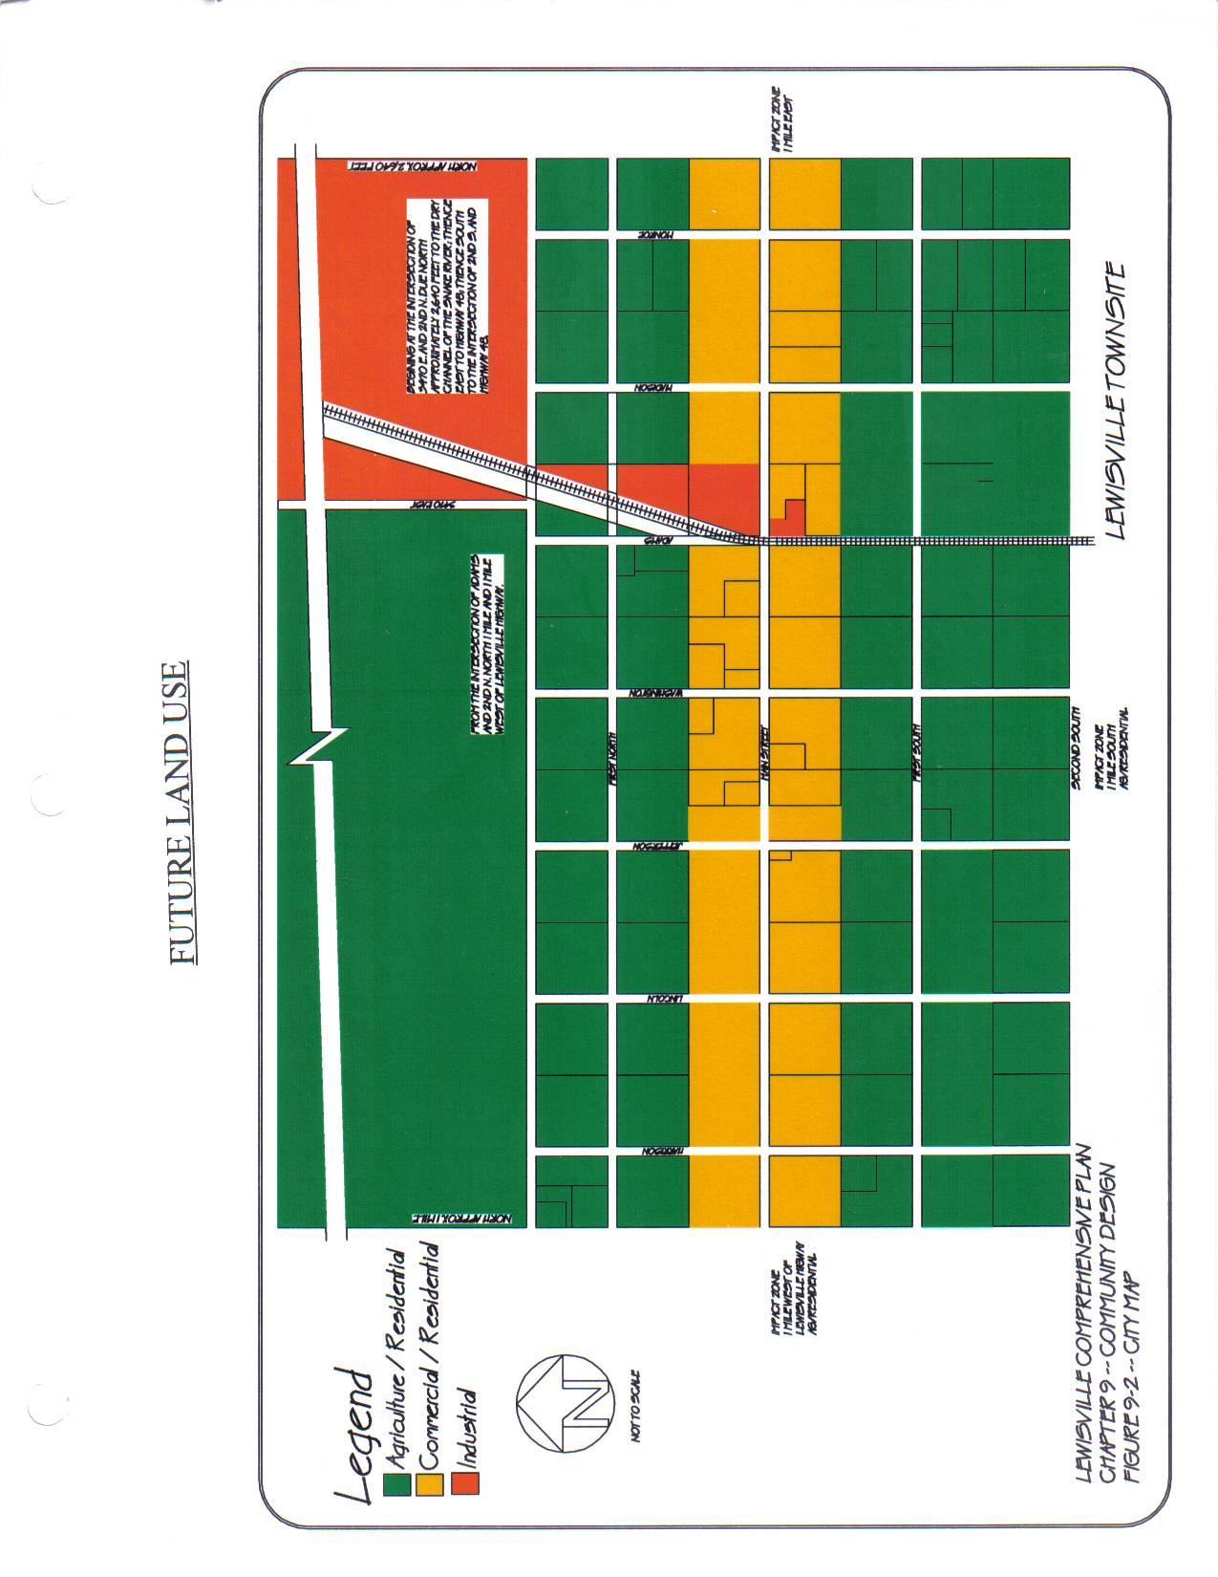

Page 9-6

(9-6 A Definition of Districts – Add )

ROADS AND TRANSPORTATION

ROADS

There are twelve roads intersecting the 36 blocks in the city grid. The roads running east and west are named for U.S. Presidents Monroe, Madison, Adams, Washington, Jefferson, Lincoln and Harrison. The roads running north and south are numbered from Main Street. All the roads are 24 feet wide and are paved and seal-coated.

ROAD MAINTENANCE

Streets in the city are maintained by part-time summer employees. Maintenance projects include repaving and repair of roads, mowing easements and grass, and trimming trees on city property throughout town. In the winter, the mayor or one of the city council members operate the snow plow.

In the past, the city council has designated a percentage of the annual budget for road maintenance funds. Currently, (1997), the city council determines the amount needed during the annual budgeting process. Beginning in fiscal year 1991-1992, $43,000 was budgeted for roads. The actual expenditures amounted to $20,000, less than the budgeted amount. The next year, 1992-1993, $45,000 was budgeted, but $52,000 was expended. In fiscal year 1993-1994, $40,000 was budgeted, but expenses exceeded the budget, and $48,000 was expended.

The budget for the next three fiscal years was much less than the previous years. In 1994-1995, $32,000 was budgeted, but only $3,500 was spent. In 1995-1996, $34,000 was budgeted, and $24,000 was spent. In fiscal year 1996-1997, $34,000 was budgeted. Expenses were $3,500 that year.

Although streets throughout the city needed repairs, the spring floods of 1997 delayed work on the streets, and the planned work was not able to be completed. During the 1997-1998 fiscal year, an asphalt lift was done on Main Street, other repairs were completed on streets and equipment, and the snow plow was replaced.

Page 9-7

TABLE 9-1 -- ROAD EXPENDITURES
Fiscal Year | Budgeted | Expended
1991-1992 | $43,000.00 | $20,000.00
1992-1993 | $45,000.00 | $52,000.00
1993-1994 | $40,000.00 | $48,000.00
1994-1995 | $32,000.00 | $ 3,500.00
1995-1996 | $34,000.00 | $24,500.00
1996-1997 | $34,000.00 | $ 3,500.00

Page 9-8

ROAD DEVELOPMENT

The city has no roads or intersections that are persistently congested. Some intersections, particularly those leading onto 3500 East or the Lewisville highway, may be crowded during rush-hour traffic. However, the wait at these intersections is not a pressing problem at this time.

Traffic flow within the city involves mostly private vehicles traveling to residences. During business hours, trucks travel down Main Street and along Adams Street from Idaho Fresh, Clements Brothers, and Lewisville Produce to adjoining highways or business addresses. Lewisville does not have a designated truck route. Other traffic on Main Street during the day includes customers for Rounds Service Station, Lewisville Library patrons, and cars pulling in and out of the LDS Church parking lot.

During the 1998-1999 school year, three school busses traveled within the city. One entered the city on First North from the Lewisville Highway, traveled to railroad tracks, then north one block, and then east on Second North to Highway 48. The second bus traveled from west to east on First South, stopping at each intersection, and then onto Highway 48. The third bus entered the city from Highway 48 on Second South, traveled two blocks west, traveled North to Main Street, and then East to Highway 48. Bus routes are subject to change each school year according to the needs of the school district.

Currently there is no future road development planned.

PARKING

Because of the size of the city and business district, it has not been necessary to provide off-street parking. Employees of the local businesses have been able to park their cars near their work. Occasionally, trucks backing into loading docks at Idaho Fresh, Clements Brothers, or Lewisville Produce may temporarily block oncoming traffic at the intersections of Main Street and Adams, but that has not been a pressing problem as yet. Angle parking is available along the city block in front of the library and community center. Although the location is convenient, the parking area tends to flood after a storm or when the city grounds are being watered in the summer, making it necessary to wade through mud and water to reach the sidewalk. There are no plans to provide parking lots or improve parking spaces at this time.

SPEED LIMITS

The posted speed limit throughout the city is 35 miles-per-hour. Speed limit signs are posted at First South and Harrison, First South and 3500 East, Main Street just below 3500 East, Main Street just above the Lewisville Highway, and Second North just below 3500 East. There are no plans to add signs in the near future.

Page 9-9

TRANSPORTATION

Lewisville City is within a few miles of state and federal highways and Interstate 15. The area is served by Eastern Idaho Railroad, which bisects the city from Second South to Second North adjacent to Adams Street. Idaho Falls Airport is about ten miles south of Lewisville; and, smaller airports are located in Rigby, about five miles east of Lewisville, and in Rexburg, about 17 miles north of the city. A CART bus services the Grant area only for people with special needs. CART authorities hope service will be extended to the Lewisville area in the future; but, at the present, time there are no plans to do so.

Page 9-10

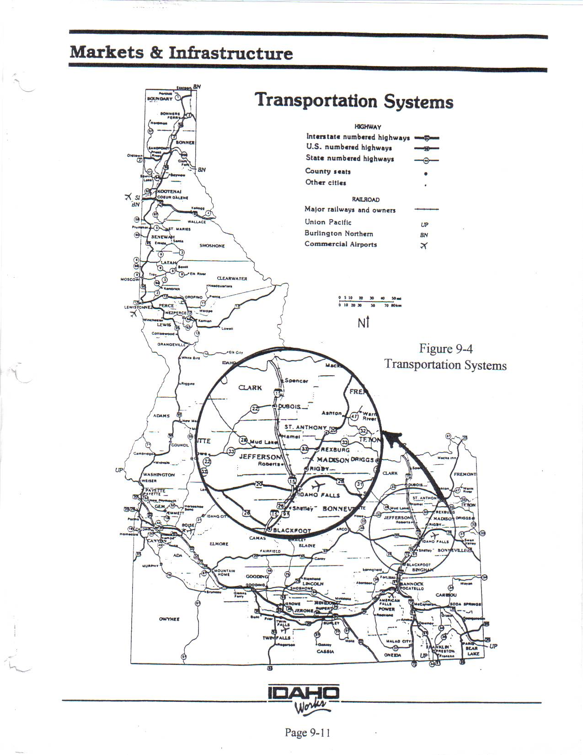

Page 9-11

